

Dr. Brian, Chambers inc.
2017-04-07
Dr. Chambers
PSC 4001, Box 2686, APO AA 77790
Phone: 1385819858
Fax: 4206158675

Re: Brenda, Cook
PHN: 6738869015
Birthdate: 18-Oct-1982
Address: 293 Hurley Trafficway Suite 002, North Davidville, HI 22133
Patient number: 3005825563

To Whom It May Concern:

This is a medical letter to state the above patient is pregnant with expected delivery date of 07-Jun-2025. Hoping this information is satisfactory for your requirements.

Thank you.

Sincerely,
Dr. Brian, Chambers
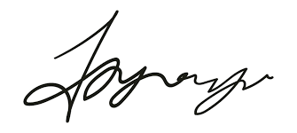
FRCS© NCMP
Clinical Assistant Professor, UBC
Department of Obstetrics and Gynecology SMH

